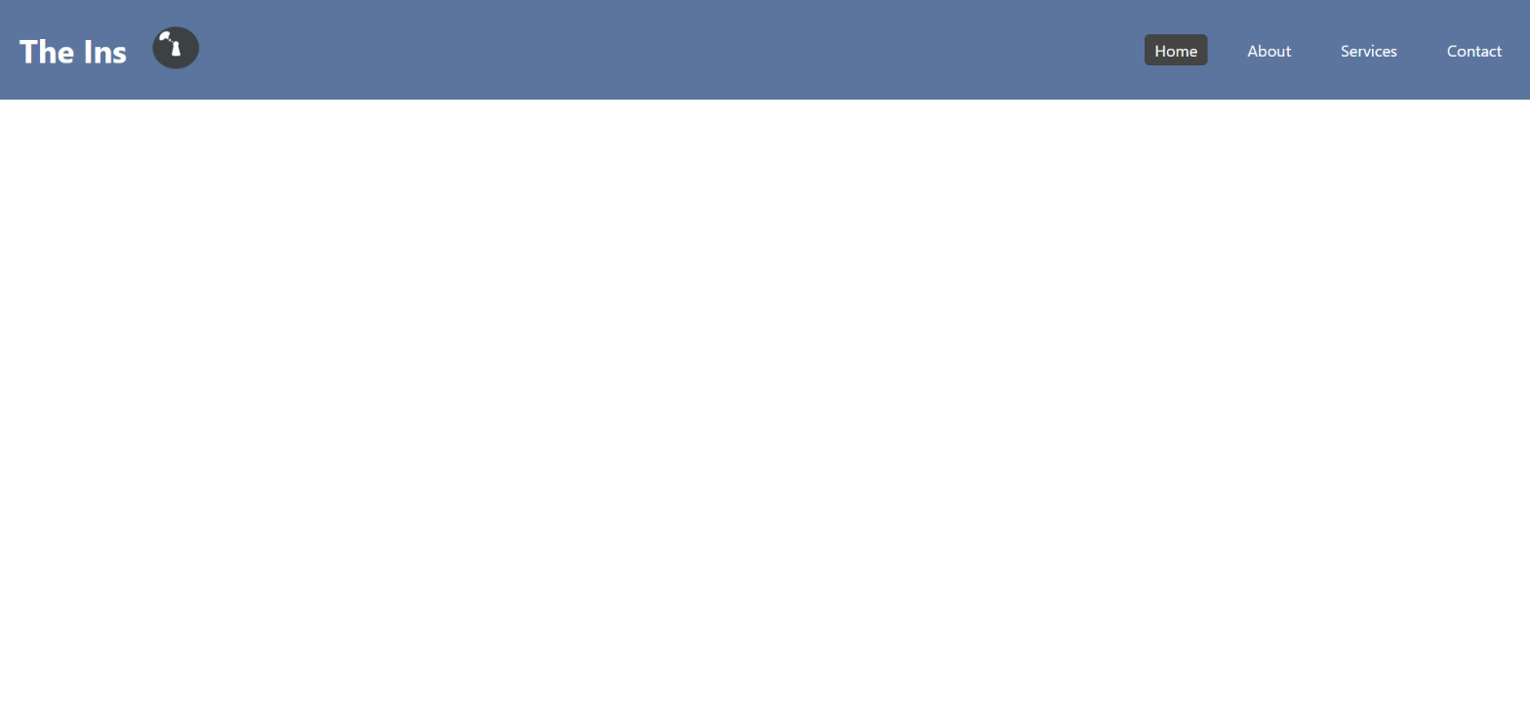

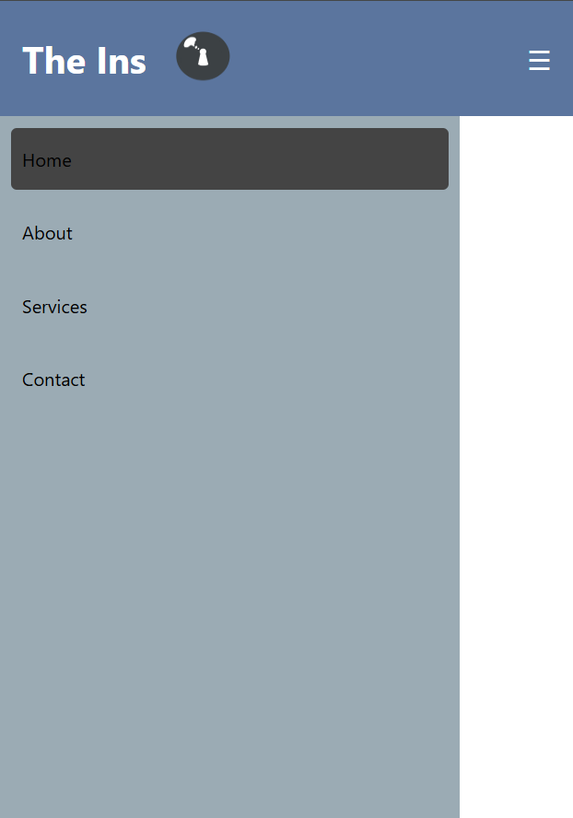

Reflection

For this study, the navigation is adaptable to mobile resolution. We have a state were the navigation links hides and a burger icon pops. The navigation links then shows itself by clicking the burger icon. The toggle is done by putting event listener for when the button is clicked (isMenuOpen), so we as a user can interact with it. The asychronous behavior was used for the navigation links. Where they click a navigation link in any order and will indicate a page is loading then page is loaded. These are all done NOT in a specific order as it is shown in the (setTimeout).

Event Bubble is where a child element propagates upward through its ancestors in the Document Object Model (DOM). Think of it like a bubble forming itself and slowly floating to the top. This usually happens when a user interacts with an element that contradicts with each other, causing the child element to bubble up and log first before the parent does.

